Ammar Kandil 900202041 Report Assignment 4

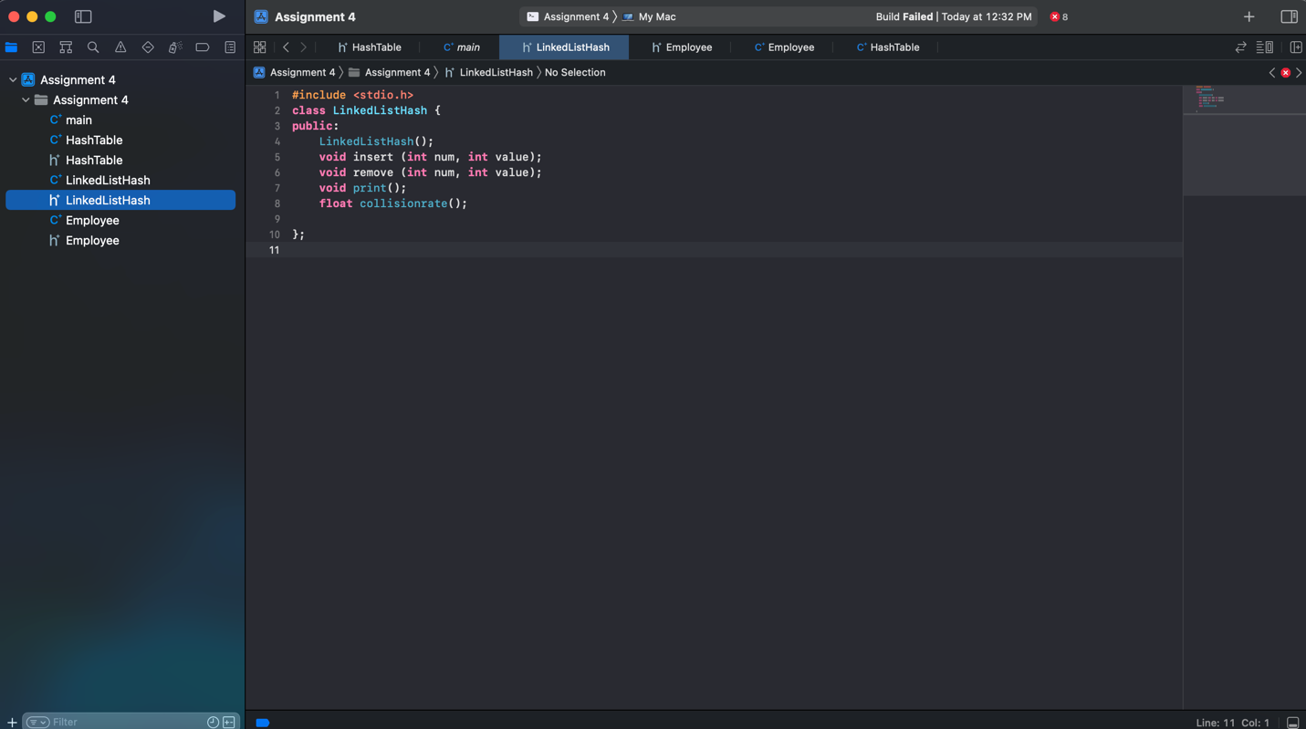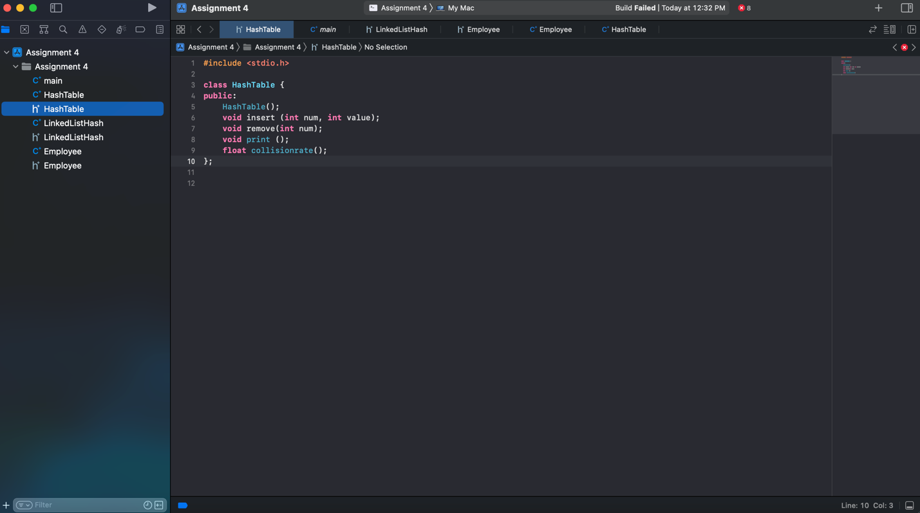

Here we can see that we will apply a function that will calculate the collision rate.

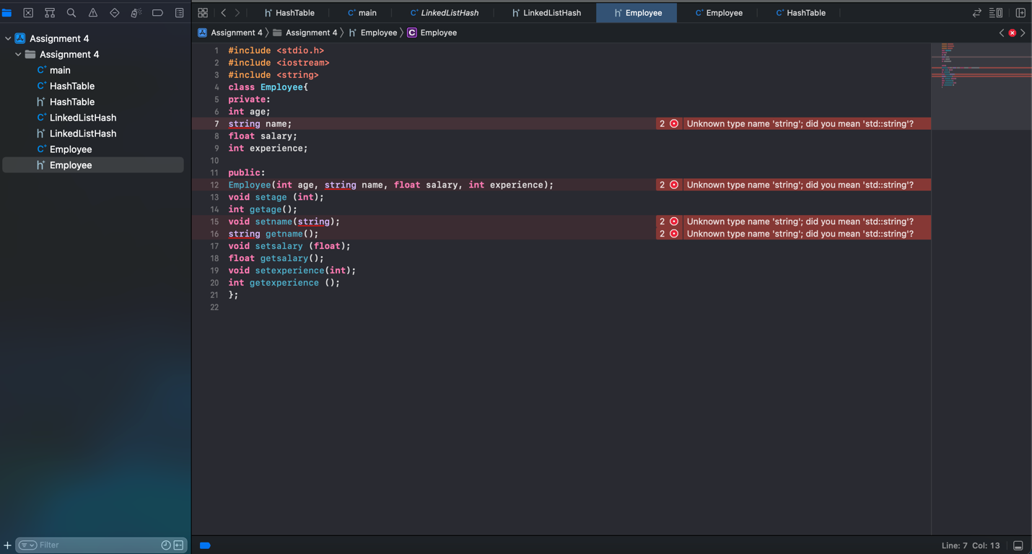

Creating the class employees by defining age, salary, name and experience.

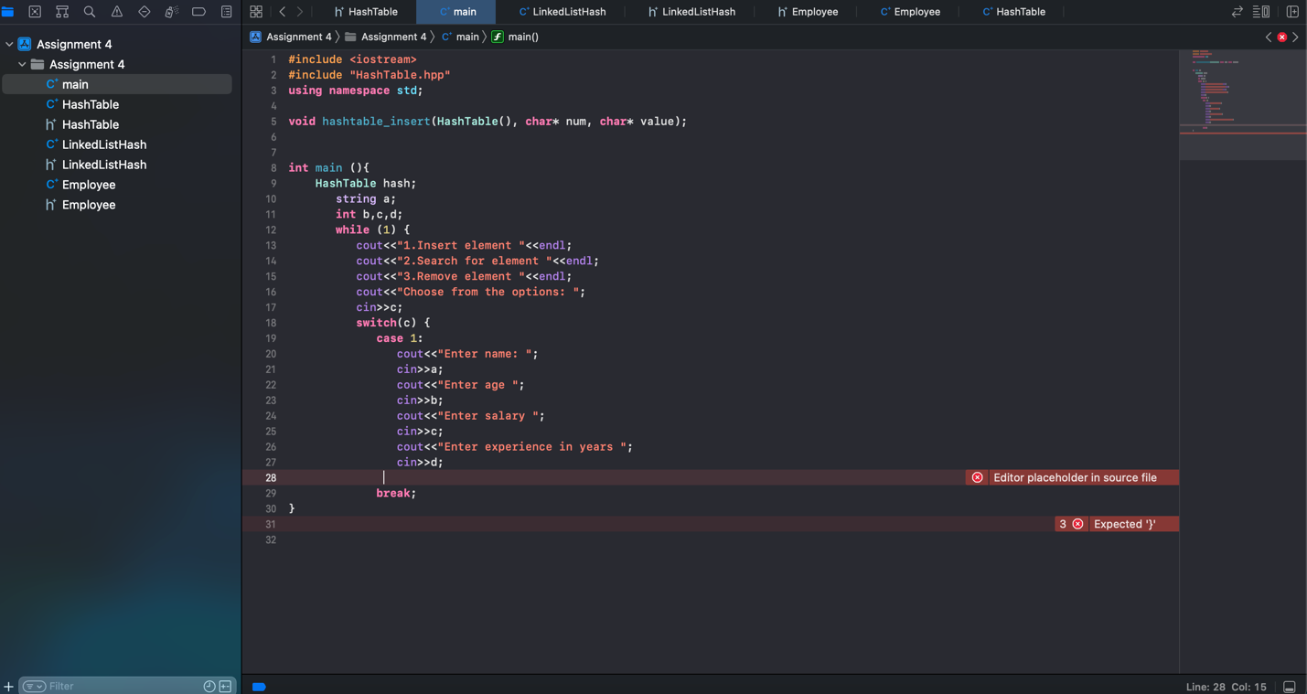

There are some problems connecting the classes to the main, however they are working separately.